Name: Weekly Language Review – Q1:3 Date:
Monday | Tuesday | Wednesday | Thursday
Write the word.  up | Write the word.  to | Write the word.  go | Write the word.  in
Circle the letters that should be capitalized.  she is my friend. | Circle the missing ending punctuation.  ! . ?  What is her name___ | Circle the letters that should be capitalized.  the book was great. | Circle the missing ending punctuation.  ! . ?  Don’t touch that___
Color the NOUNS blue.  Color the VERBS green.  key run  pillow jog | Underline the NOUN in the sentence.  I sat in the chair. | Color the NOUNS blue.  Color the VERBS green.  fan play  eat cake | Underline the VERB in the sentence.  She plays with her sister.
Circle the words that are vehicles.  car rock shoe  road truck  tree van leaf | Write a word that is a vegetable.  _____________________ | Circle the words that are things you read.  fork book spoon  table magazine  newspaper | Write a word that is a  toy.  _____________________
Circle the picture that matches the word.  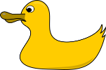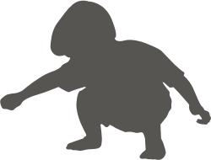  The duck swam. | Circle the picture that matches the word.  Duck under the table. | Circle the picture that matches the word.  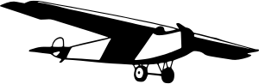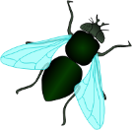  The fly landed on your food. | Circle the picture that matches the word.  The plane will fly over the ocean.
Circle the word that completes the sentence.  ate eight   8  My dad _____ all of his food. | Draw a line to match the homophones.  would ant  sea wood  aunt see | Circle the word that completes the sentence.  sale sail    The store is having a _____. | Draw a line to match the homophones.  by red  read four  for bye
My Work
Monday  __________________________________________________________________________________________________________________________________ | Tuesday  __________________________________________________________________________________________________________________________________
Wednesday  __________________________________________________________________________________________________________________________________ | Thursday  __________________________________________________________________________________________________________________________________

My Progress
MONDAY  Out of _____ questions, I got ______ correct. | TUESDAY  Out of _____ questions, I got ______ correct. | WEDNESDAY  Out of _____ questions, I got ______ correct. | THURSDAY  Out of _____ questions, I got ______ correct.

Answer Key - Weekly Language Review – Q1:3

Monday | Tuesday | Wednesday | Thursday
Write the word.  up | Write the word.  to | Write the word.  go | Write the word.  in
Circle the letters that should be capitalized.  She is my friend. | Circle the missing ending punctuation.  ! . ?  What is her name___ | Circle the letters that should be capitalized.  The book was great. | Circle the missing ending punctuation.  ! . ?  Don’t touch that___
Color the NOUNS blue.  Color the VERBS green.  key run  pillow jog | Underline the NOUN in the sentence.  I sat in the chair. | Color the NOUNS blue.  Color the VERBS green.  fan play  eat cake | Underline the VERB in the sentence.  She plays with her sister.
Circle the words that are vehicles.  car rock shoe  road truck  tree van leaf | Write a word that is a vegetable.  Answers will vary.  carrot | Circle the words that are things you read.  fork book spoon  table magazine  newspaper | Write a word that is a  toy.  Answers will vary.  ball
Circle the picture that matches the word.  The duck swam. | Circle the picture that matches the word.  Duck under the table. | Circle the picture that matches the word.  The fly landed on your food. | Circle the picture that matches the word.  The plane will fly over the ocean.
Circle the word that completes the sentence.  ate eight  8  My dad _____ all of his food. | Draw a line to match the homophones.  would ant  sea wood  aunt see | Circle the word that completes the sentence.  sale sail  The store is having a _____. | Draw a line to match the homophones.  by red  read four  for bye

